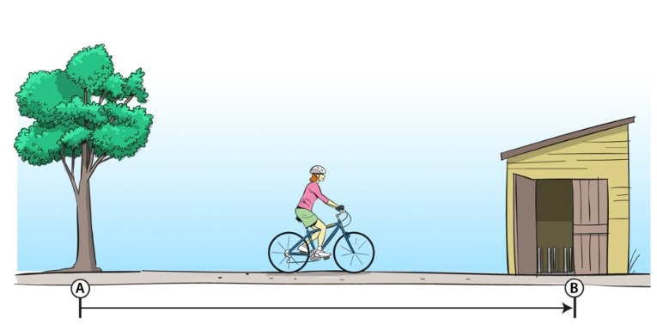
Questions on Displacement
Task A
Figure 1: Displacement

Refer to this picture when answering questions 1, 2, and 3.

It is 10 m along a straight path from the tree to the shed.

Q1 What is the displacement of B from A?

Q2 At the location shown what is your estimate of the displacement of the bike from A?

Q3 If the cyclist gets to B then goes back to A, what distance will she have travelled? What will be her displacement from A?

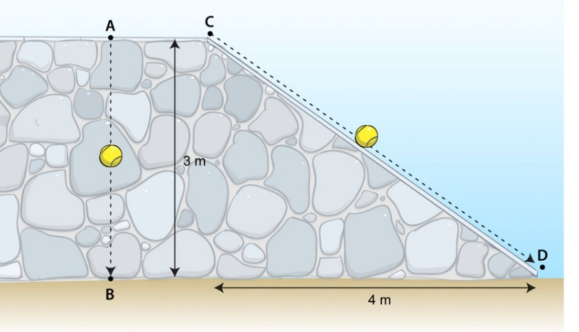
Task B
Figure 2: Vertical displacement

Refer to figure 3 when answering questions 5, 6, 7 and 8.

The top of the wall is taken to be level, and parallel with the ground.
Q5 What will be the vertical displacement of the ball on the left once it moves from A to B?

Q6 What will be the vertical displacement of the ball on the right once it moves from C to D?
_________________________________________________________________
*Q7 What is the distance travelled by each ball?

_________________________________________________________________
Q8 What is the vertical displacement of any ball moving from the top of the wall to the bottom?

